- --Security Group of the Bastian Host
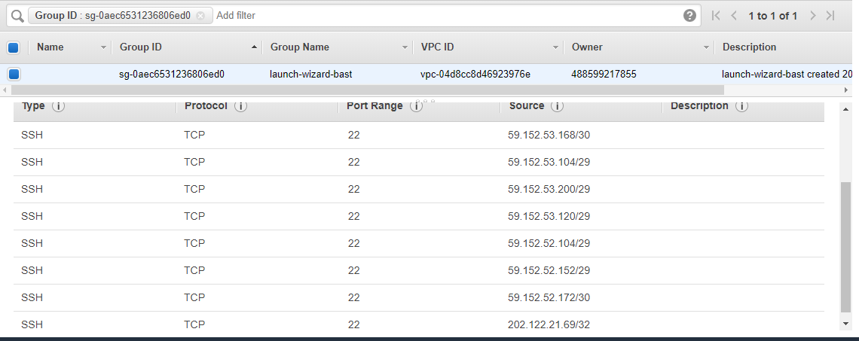

- -- Security Group of the Private Server 1
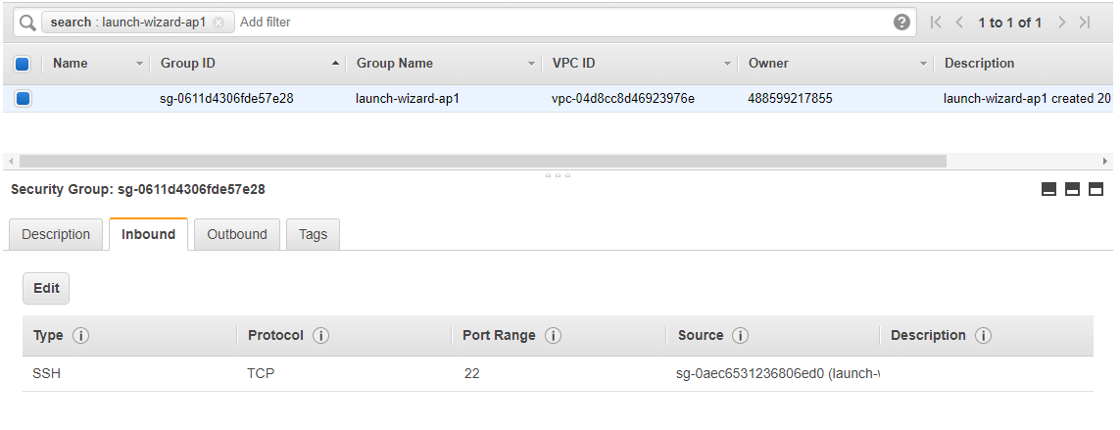

- -- Security Group of the Private Server 2
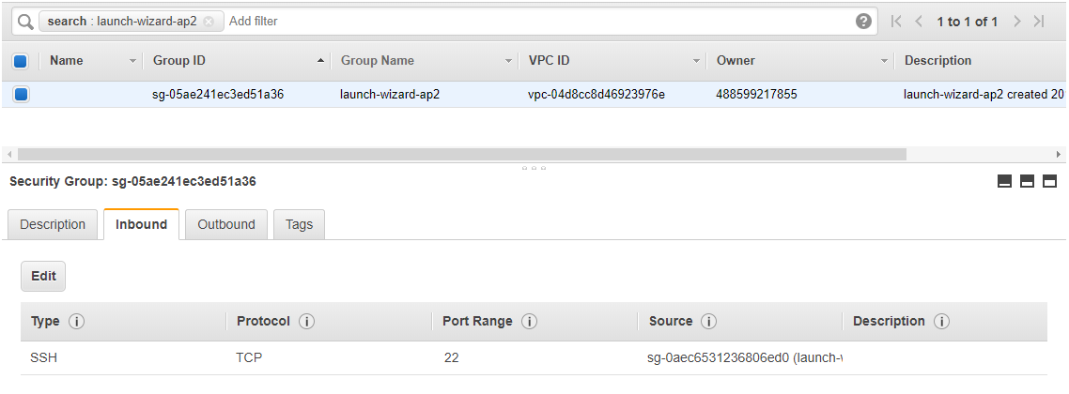

4)-- Security Group of the Private Server 3
